**DAILY ONLINE ACTIVITIES SUMMARY**

|  |  |  |  |  |  |  |  |  |
| --- | --- | --- | --- | --- | --- | --- | --- | --- |
| **Date:** | **07/06/2020** | | | | | **Name:** | **NIKHIL KUMAR** | |
| **Sem & Sec** | **4thSEM. & ‘B’ SEC.** | | | | | **USN:** | **4AL19CS400** | |
| **Online Test Summary** | | | | | | | | |
| **Subject 1** | | **NIL** | | | | | | |
| **Max. Marks(DC)** | | **NIL** | | **NIL** | | | **NIL** | |
| **Certification Course Summary** | | | | | | | | |
| **Course** | **Java programing** | | | | | | | |
| **Certificate Provider** | | | **Greatlearning**  **Academy** | | **Duration** | | | **3.5 Hrs.** |
| **Coding Challenges** | | | | | | | | |
| **Problem Statement : Write a c++ program to swap two numbers using friend as a bridge concepts.**  **Example :**  **Input :**  **a=10, b=20**  **Output:**  **a=20, b=10** | | | | | | | | |
| **Status:executed** | | | | | | | | |
| **Uploaded the report in Github** | | | | | **Yes** | | | |
| **If yes Repository name** | | | | | **1.**<https://github.com/Nikhil401/c-codding/blob/master/Swap.cpp> | | | |
| **Uploaded the report in slack** | | | | | **Yes** | | | |

**Certification Course Summary: Today I have finished my certification course “java programming” and the snapshot of the certificate is given below:**

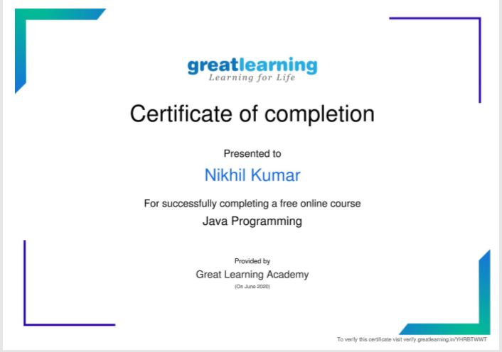

**Online Coding Summary: Today I received one program from prof . Shilpahassan CSE Dept. The program is mentioned above(pg.01). to my GitHub repository link and I’ve shared the snapshot below. 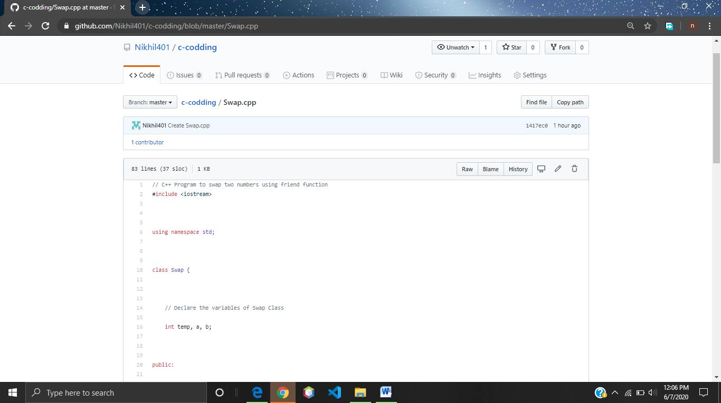Thank you.**